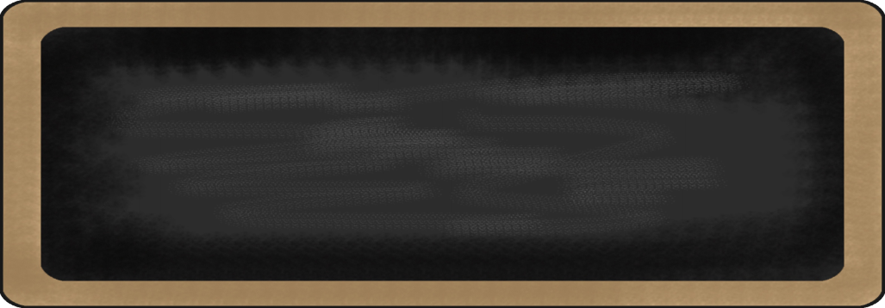

Spelling Words

1. first
2. birds
3. turn
4. start
5. short
6. north
7. are
8. were
9. word
10. world

MC900134537[1]

**Upcoming events**

**11/20/13 – Early Release**

**11/27/13 – 11/29/13 – Thanksgiving Break – NO SCHOOL**

|  |  |  |  |
| --- | --- | --- | --- |
| **reading** | **Writing** | **Math** | **Social Studies** |
| * I can ask and answer questions to understand key details. | * I can compose a variety of writing pieces. | * I can do double digit +/- with regrouping. | * I can explain the importance in promoting common good. |

MC900232760[1]

MC900290673[1]

Notes from the teacher:

* Specials for next week:
  + Lecuru – MPAAM
  + Lucas – PAMMP
  + Capper -AMPPA
* Library: **NOTICE CHANCE**
  + **All classes will be now going to library on Friday.**

Spelling Sentences:

1. Where in the world are those birds?
2. Were you the first girl to start a trip to the north pole?

MC900290705[1]

MC900089728[1]

MC900237619[1]

Happy Birthday in November:

Molly 14th

Katie 30th

What we are learning this week:

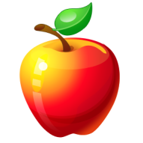

**Contact Information** (816)892-1650

[Jamie.Lecuru@raypec.org](mailto:Jamie.Lecuru@raypec.org) [Melissa.Lucas@raypec.org](mailto:Melissa.Lucas@raypec.org) [Sheri.Capper@raypec.org](mailto:Sheri.Capper@raypec.org)

